**Computer Science & Software Engineering**

**Basic Control Circuits**

Name: __________________

Date: _______ Period _____

Technology Education Dept

Pittsford Central Schools

**Introduction**

All of the chips and circuits that we use today are constructed from some fairly simple building blocks. While modern programming languages allow developers to work at a very high level of abstraction some of the same functionality can be achieved directly with electronic components!

**Materials**

* Electronic breadboarding kit
  + 2 x NPN Transistor 2N2222 or equivalent
  + 2 x LEDs
  + 1 x 74LS00 Integrated Circuit
  + 1 x 5 volt regulator (for use with 9Volt battery)
  + 2 x push buttons
  + 2 x 1kΩ ¼ watt resistors (Brown/Black/Red/Gold)
  + 4 x 220Ω ¼ watt resistors (Red/Red/Brown/Gold)
  + 1 x Electric Motor
  + 1 x Ultrasonic Sensor

Procedure

**Part I: Transistor, Gates, Microcontrollers, and Microprocessors  
Researching and Understanding the Building Blocks**

1. ***[K2.15*]*** Research and answer the following questions in your own words. Make sure you can defend the reliability of the sources used.
2. What does a transistor do and why is it important?
3. Why are modern transistors so much better for building modern circuits than modern vacuum tubes?
4. Vacuum tubes are still commonly used in some devices today. Give an example.
5. Microprocessors are an example of a VLSI device. What does VLSI stand for and why does it affect how you live your life?

Part II: Discrete Components:  
Building and Testing a NAND Gate Circuit

Electronic devices that are constructed as single units (such as transistors and resistors) are called discrete components. Combinations of discrete components can be created that produce logic gates. Logic gates can then be grouped into an Integrated Circuit (IC). Finally, Microcontrollers and microprocessors represent very large numbers of transistors to create the complex abilities of today’s electronic devices.

The components that you will use in the rest of the lesson include a solderless breadboard. The breadboard is a place where you can try out different circuit configurations. In electronics, truth tables are used to describe the function of a logic gate.

**Logic Gates from Transistors**

1. Based on the names of these three fundamental logic gates, can you guess what the logic output for each would be?

**INVERT Logic Gate – (1) input (1) output**

The output is opposite the input.

|  |  |
| --- | --- |
| INVERT | |
| Input A | Output |
| 0 |  |
| 1 |  |

**OR Logic Gate – (2) inputs (1) output**

The OR logic gate has a similar gate with the exact opposite logic called a NOR gate.

|  |  |  |  |  |  |  |
| --- | --- | --- | --- | --- | --- | --- |
|  | OR |  |  | NOR (Not OR) | | |
| Input | | Output | Input | | Output |
| A | B | A | B |
| 0 | 0 |  | 0 | 0 |  |
| 0 | 1 |  | 0 | 1 |  |
| 1 | 0 |  | 1 | 0 |  |
| 1 | 1 |  | 1 | 1 |  |

**AND Logic Gate – (2) inputs (1) output**

The AND logic gate has a similar gate with the exact opposite logic called a NAND gate.

|  |  |  |  |  |  |  |
| --- | --- | --- | --- | --- | --- | --- |
|  | AND |  |  | NAND (Not AND) | | |
| Input | | Output | Input | | Output |
| A | B | A | B |
| 0 | 0 |  | 0 | 0 |  |
| 0 | 1 |  | 0 | 1 |  |
| 1 | 0 |  | 1 | 0 |  |
| 1 | 1 |  | 1 | 1 |  |

Transistors can only have two states (on or off). In electronics, we can also describe these two states as (high/low) or (0/1).

In this part of the activity, we are going to create a NAND logic gate from discrete components (transistors and resistors).

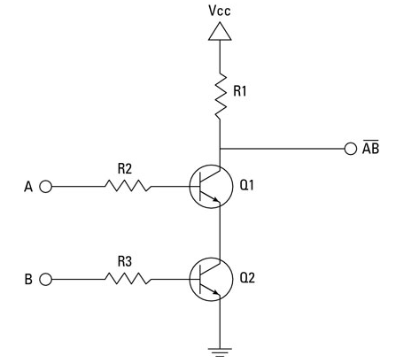

The NAND gate is very special because you can use multiple NAND gates to construct any other logic gate and as a result, any circuit! NAND stands for "NOT AND". NOT means take whatever the output should be of an AND gate and make it the opposite.

Here is the schematic drawing for an AND gate and a NAND gate. Notice the similarities. What symbol is used to indicate the “NOT” in the schematic drawing?

|  |  |  |
| --- | --- | --- |
| AND |  | NAND (Not AND) |
| AND ANSI Labelled.svg |  | NAND ANSI Labelled.svg |

1. Obtain a breadboarding kit and form pairs as directed by your instructor.
2. Using the precut lengths of wire and components provided by your instructor, construct the circuit shown in the diagrams below using the step-by-step instructions. As you construct this circuit **make sure that none of the components are touching one another before you supply power**.
3. The electronic components that you will use in this activity only safely and reliably function within a range of about 4.75V to 5.25V. In order to ensure a reliable circuit, you will first connect the power supply to a 5V voltage regulator as shown and described.

* Insert the black lead from the 9V battery into the ground rail (blue) on your breadboard. Do not connect the red lead until you are sure everything is correct.
* Run black wire from the GND rail to J29.
* Run red wire from the red (hot) rail to J28.
* Insert the 5V regulator in locations I28-I30 with the heat sink facing away from the wires that you have just inserted.
* Run a black wire from the blue rail on one side of the breadboard to the blue rail on the other side.
* **DO NOT connect the hot wire from the 9V battery yet.**

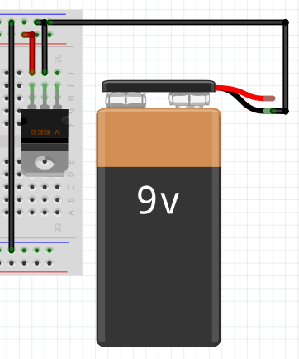

1. Now you will place input switches with which to control your circuit and 1k ohm pull down resistors.

* Run red wire from the hot rail to both J1 and J4.
* Connect I1 and I4 to GND using 1k ohm resistors.
* Insert the pins from one side of a push button switch at F1 and F3.
* Insert the pins from one side of the other push button at F4 and F6.
* Run blue wire from G3 to I8.
* Run blue wire from G6 to F10.

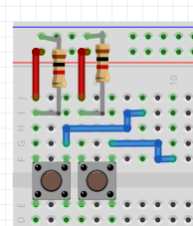

1. The NPN transistors that you use should be placed so that the side with the writing (the flat side) is facing toward the bottom of the diagram. In this orientation the collector is the right pin, the base is in the middle (connected to the resistors), and the emitter is on the left.

* Connect H8 and H13 with a 220 ohm resistor.
* Connect G10 and G18 with a 220 ohm resistor.
* Run red wire from H14 to H 17.
* Run red wire from H19 to H24.
* Connect J24 to the hot (red) rail using a 220 ohm resistor.
* Insert the transistors facing the wires you just put in in positions I12-I14 and I17-I19. The flat side of the transistor must face away from the edge of the board – see figure below.
* Run a black wire from GND on the bottom side of the board to F12.

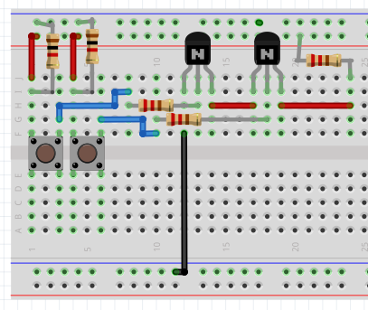

1. The long lead on the LED is the collector, and the short lead (flat side of the LED) is the emitter and should be connected to GND. The emitter lead on the LED is the one on the flat edge to the rim around the base side of the LED. It is better to locate the emitter lead by the flat edge instead of by the length of wire, in case the LED wires have been bent or cut.

**Helpful Hints:**

“Always be more positive than negative” – Longer lead goes to positive.

“Notch Negative” – Notched edge on the LED goes to negative.

* Insert the collector lead from the LED into F24 and the emitter lead into F25.
* Run a black wire from J25 to GND.
* Finally connect the hot lead from the 9V battery to J30.

When you are done, your circuit should look like this:

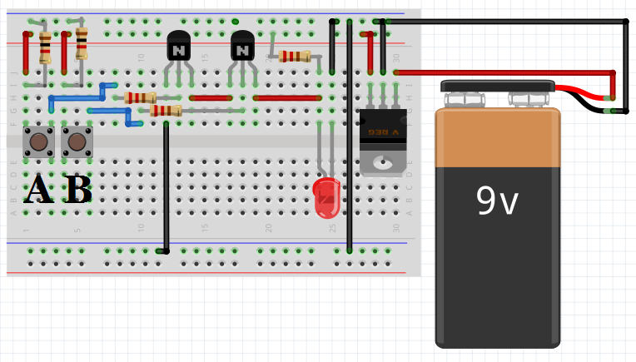

1. Use the push buttons to verify that this is a working NAND circuit and checking the result against the truth table.

|  |  |  |
| --- | --- | --- |
| NAND (Not AND) | | |
| Input | | Output |
| A | B |
| 0 | 0 |  |
| 0 | 1 |  |
| 1 | 0 |  |
| 1 | 1 |  |

1. Take a digital picture of your working circuit for your engineering notebook or electronic portfolio as directed by your teacher.
2. You could use the output from the NAND gate you've created, which currently goes to the LED, as an input for some other gate. Why might you want to do something like that?

**Part III: Integrated Circuits (ICs): The 74LS00 IC  
Creating an AND gate from Two NAND Gates**

The transistors you used in the last part of this activity were very large to facilitate bread boarding. The 74LS00 integrated circuit (IC) contains NAND logic gates and is breadboard able.

What would happen if you tied the output of one NAND gate to both inputs of a second NAND Gate? If INPUT A and INPUT B are always identical going into the second NAND gate, you really only have (1) input (ON/OFF) and (1) output.

What fundamental logic gate is the second NAND gate now behaving as?

The two gates together are producing a truth table that would look like what gate?

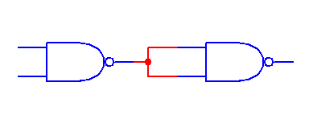

We will use the 74LS00 integrated circuit (IC) to construct an AND gate. Look at the schematic that is shown on the left, for this integrated circuit which is shown on the right. Notice that both have a semi-circle notch to help identify the short edge that has pin 1 and pin 14.

|  |  |
| --- | --- |
| http://www.seekic.com/uploadfile/ic-data/200942512456885.jpg | http://upload.wikimedia.org/wikipedia/commons/thumb/2/26/7400.jpg/330px-7400.jpg |

1. The diagram above shows the **pinout** for the 74LS00. A pinout describes the function of each of the leads coming off the chip. VCC represents where the current comes into the chip and GND represents where the current leaves. Create a new circuit as set forth in the following steps:
2. Remove the red lead connecting the breadboard to the 9V battery to make sure your breadboard is not live (meaning that there is no electricity on your breadboard).

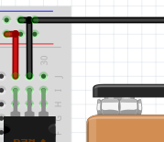

1. Remove all the components between row 1 and row 26 leaving only the red wires at rows 1 and 4, the two switches, and the blue wires at rows 3 and 6.

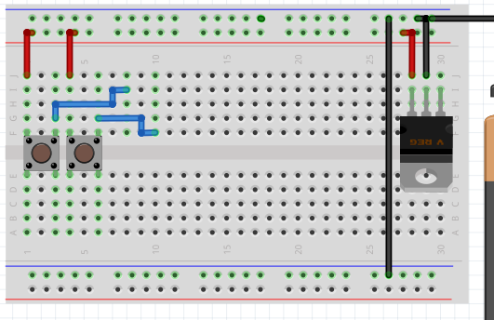

1. Reposition the rightmost ends of the blue wires to positions H9 and I10 and run red wire from the hot rail to J8.

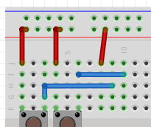

1. Add 220 ohm resistors from GND to I3 and J6.

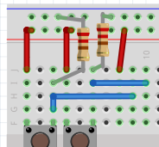

1. Touch something metal to discharge any static electricity on your person and then insert the 74LSoo in positions F8-E14. Make sure that the semi-circle notch of the 74LS00 is pointing towards the push buttons.

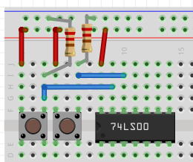

1. Run blue wire from G11 to H12, from G12 to G13, and from G14 to G16.

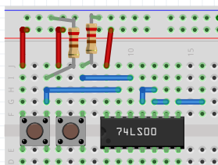

1. The following steps will complete your AND gate:

* Run black wire from GND to A14.
* Insert the LED with the collector (long lead) at F16 and the emitter (short end / flat edge of base) at F17.
* Connect I17 to GND using a 220 ohm resistor.
* Finally, connect the hot lead from the 9V battery to J30. Your finished circuit should look as shown below.

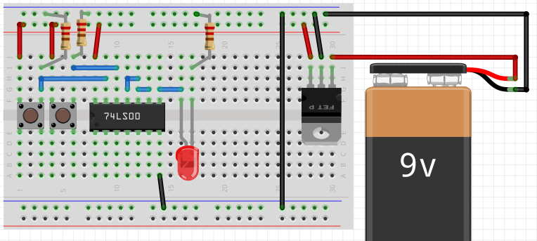

1. Use the push buttons to verify that this is a working AND circuit and check the result against the truth table.

|  |  |  |
| --- | --- | --- |
| Input | | Output |
| A | B |
| 0 | 0 |  |
| 0 | 1 |  |
| 1 | 0 |  |
| 1 | 1 |  |

1. Take a digital picture of your working circuit for your engineering notebook or electronic portfolio as directed by your teacher.

NAND gates are often referred to as “Universal Gates” because you can create all other logic gates using only NANDs. In this Part of the activity you have just created an AND gate!

**Part IV: Logic Applications: Making Things Move**

Now that you understand how to create hardwired logic using discrete components and ICs, let’s use that knowledge to do something (other than turn on an LED).

In the circuit you just created we will replace the LED with a transistor that will act like a switch, and a motor that will turn on when the logic output from the ICs triggers the transistor to allow current to flow.

In the circuit diagram below we see that when the Base of the transistor receives a signal, current is able to flow through the LED. This type of transistor operates best under certain specifications. In this case, the current in the base is around 4.21 mA.

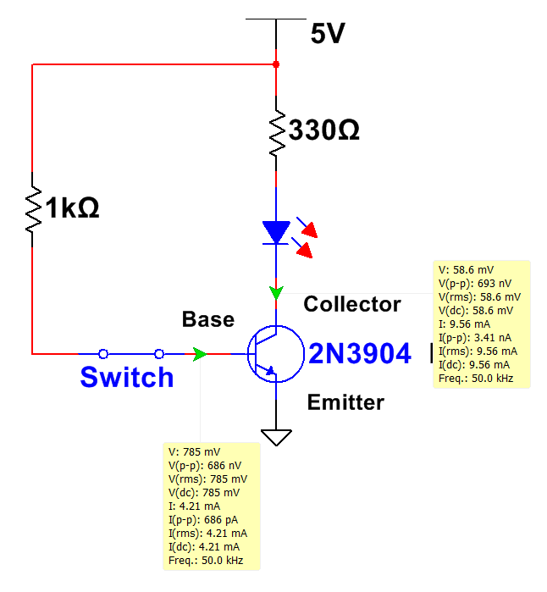

1. In the circuit diagram below we have replaced the switch from the previous circuit diagram with the AND logic circuit you created previously. Notice that the current in the base of the transistor is now the output current for our NAND IC which is 412 mA and the output voltage for our NAND IC which is 5V.

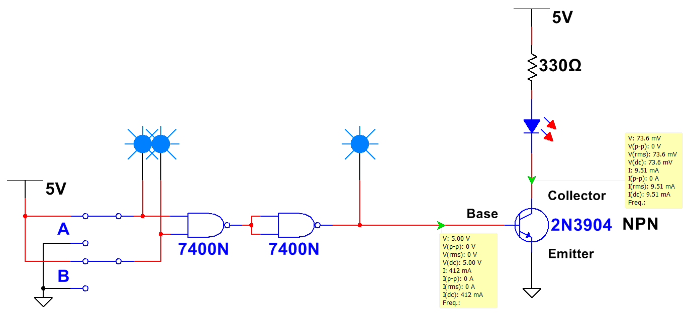

1. To limit the current we will add a 1 kΩ resistor. This reduces the chance that we will damage the transistor. The last thing we need to do is replace the LED/Resistor with our motor.

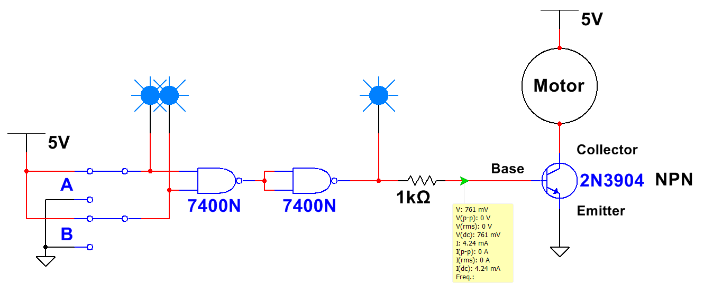

1. Create the circuit based on the circuit diagram above. Note: the motor provided in your kit is rated for 200 mA at 3V.
   1. What is the resistance due to the motor?
   2. Knowing this resistance, what then would be the current at 5V?
   3. This amount of current will not damage the motor, but if you wanted to protect this part of the circuit, what could you do?
2. An integrated circuit called an H-bridge is usually used to drive a motor instead of the single 2N3904 used here. It can drive the motor in both directions and can protect the logic gates if the motor uses a higher voltage than the circuit making the logic signals A and B. Internally, an H-bridge is made of transistors connected in a H-shape.

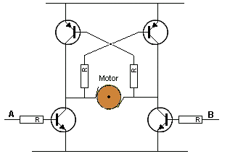

The NAND gate and the H-bridge are two examples of the relationship between transistors and integrated circuits. What is this relationship?

1. Logic gate ICs implement a transistor circuit design. There are hundreds of versions of NAND gate ICs available in catalogs of electronic components. Circuit designers using those ICs rarely have to think about those transistors. Describe why a logic gate is a good example of abstraction.
2. **Embedded intelligence and the Internet of Things.** Over 10 billion ***microprocessors*** (CPUs) and **microcontrollers** (MCUs, which are chips containing both CPU, memory, and pins for input/output **peripherals**) are sold each year. Some of these integrated circuits cost less than $1. Solutions for many problems involve creating both software and a circuit incorporating one of these ICs.

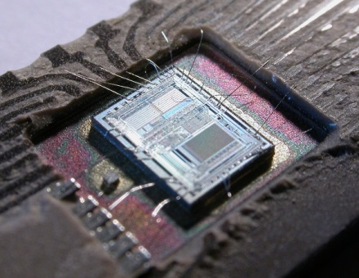

Approximately 18 million people on earth know how to code. Some of them create solutions by programming microcontrollers and designing circuits that use the MCUs to control machines, home appliances, and the burgeoning Internet of Things. The typical car has 30 MCUs, each preloaded with a program.

Count the devices in your home that you think include an MCU or CPU. List them.